REAL TIME WEATHER MONITORING SYSTEM

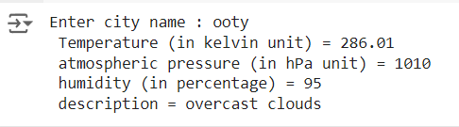

Inventory management stock analysis

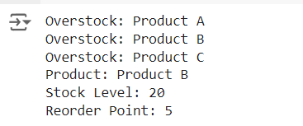

Real time covid-19 diseases tracking analysis

